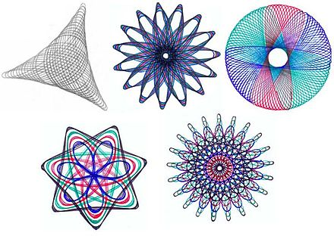

The goal of this lab is to show you how python can generate G-Code. You are tasked with implementing a virtual spirograph that generates hypotrochoid and epitrochoid curves (<https://www.wikiwand.com/en/Spirograph> You will hand in a Jupyter notebook as a .ipynb and include images of your curves and insert your G-code files. If you have a printer run it on your own machine using a pen attachment include a photo of your curves drawn on paper. If using our printers, include a screencap of the end-product and the g-code. For questions 1 and 2 make one function that generates a list of points and another that takes the list of points and writes them to g-code file.

1. write code in the imperative style (For/while loops) a virtual spirograph that makes hypotrochoid and epitrochoid curves. Plot the points using the provided code. Then output the curve as a g-code file. Make sure that the curve starts and stops on the same point. The plot the curve using the provided code.
2. Using the same jupyter notebook, write code in the functional style (map, filter,reduce, lambda functions, without state) that does the same thing as 1.
3. Run one of them on the Printer